AIS Math

## ~~~Mrs. Maderer 2018-19~~~

CONTACT INFORMATION WHAT TO EXPECT



MRS. MADERER

mmaderer@frontiercsd.org

Phone: 926-1730 ext. 3246

Email is the quickest way to get a hold of me. I check this throughout the school day!

**EXTRA HELP**

I am available for help at various times throughout the day, as well as after school. Students should come see me to set up a time to meet that will work for both of our schedules.

Welcome to AIS Math! My goal is to help you become confident in your mathematical skills and capabilities. I will share with you a variety of different strategies, methods and tips to strengthen your math abilities. You will learn how to problem solve, reason and use logic to think like a mathematician.

NEEDED SUPPLIES

* Binder (1 inch or 1.5 inch)
* pencil

GRADING



AIS is designed to support students mathematical skills and practices. At the end of each quarter students will receive a **satisfactory** or **unsatisfactory** grade based on their participation in daily class activities and assignments.

CLASSROOM EXPECTATION CONSEQUENCES 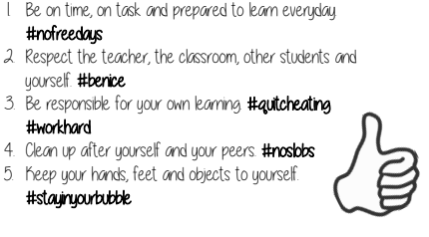

1. A verbal warning
2. 13th period
3. Contact Home
4. Referral

Policies

## ~~~Mrs. Maderer 2018-19~~~

PROCEDURES REQUIREMENTS FOR EXITING AIS

1. Be on time to class.
2. Check the front board for instructions.
3. Grab all necessary materials.
4. Complete the warm-up.

Attendance

Effective effort in both the AIS and regular classroom.

Completion of homework in your regular math classroom.

Proof of improvement on assessments.



Committee recommendation

**Please note:** A committee comprised of Mrs. Maderer, your classroom teacher, your counselor and an administrator will meet quarterly to discuss student progress.

PARENTS



Our goal is to provided your child with additional time and support in a small group setting in an effort to better ensure success in math this year and in years to come. In order to help your child succeed, I invite you to take an active role and join our team. Please feel free to contact me. I look forward to working with you and your child this year.

Failure is so important. It is the ability to resist failure or use failure that often leads to greater success.

~J.K. Rowling~

**PLEASE RETURN THIS PAGE TO SCHOOL**

Student’s Name ____________________________ Math AIS Class Period _________

Math Teacher’s Name _______________________ Day    1  2 (please circle)

Birthday _____________________

#### Contract Signature Page

Parents and Students please sign below to indicate that this contract has been read, discussed and understood.

________________________ ________________________

Student Name (Please Print) Student Signature

________________________ ________________________

Parent Name (Please Print) Parent Signature

__________________________________________________________________________

\***PARENTS FILL OUT ONLY, PLEASE\***

### Contact Information

**Please number the order in which you would like to be contacted first.**

|  |  |  |  |  |
| --- | --- | --- | --- | --- |
| Names of Parent/Guardian | Home Phone Number ____ | Cell Phone Number ____ | Work Phone Number ____ | E-mail Address |
|  |  |  |  |  |
|  |  |  |  |  |