Name:________________________

1. Click Log in

Click





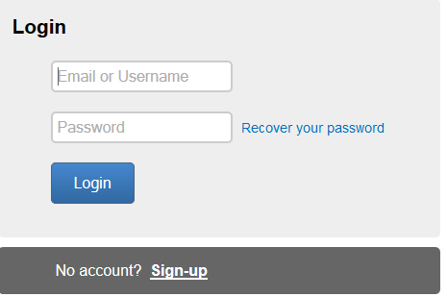Enter the username and password given by your teacher.

1. Click create new book or find your story if you have already started.

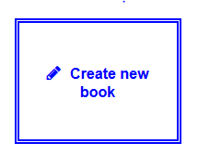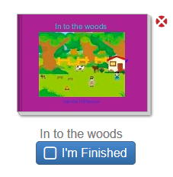

1. Click the edit button if you already started your story.

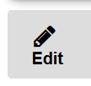

1. 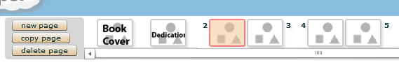

Use the top bar to move to a different page.

1. Add a scene. This is the setting of your story. Click on a scene to add it to a page. If you want to change it click the clear link. Click more scenes to get more backgrounds.

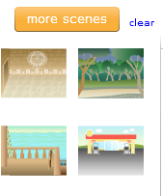

1. Add props

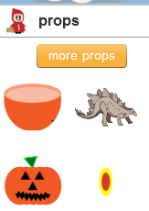 Click a prop to add it to your pages. Make sure you are clicked onto the page you want to add the prop. Click More Props to access more props. There are many pages of props.

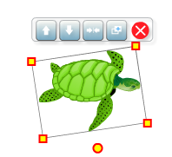Click on the yellow boxes to change the size the prop. The yellow circle will change the angel. Click the red X to delete the prop.

1. Add Text. Select a text box. The big text box will let you type on the whole page. The smaller boxes can be resized using the yellow boxes and white hands.

