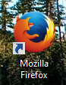 **PebbleGo Guide**

Step 1: Open Firefox or Safari. Go to Google.com and search Cloverbank Elementary Library to get to the library webpage.

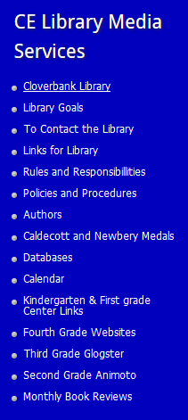Click Databases.

Choose PebbleGo . The username is **cloverbank** the password is **school.** 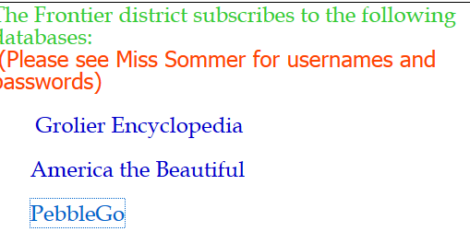

click

**Click**

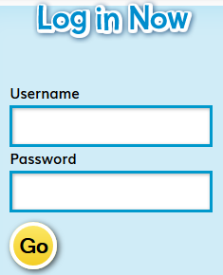 Click go after typing in the username and password.

**Click**

school

cloverbank

Step 2: Now find the search bar. Enter in your topic. 

If there is info on your topic, a red and white box will pop up. Click on the word in the red and white box.



click

Step 4: Click the tabs to read about your topic.

