**Online Encyclopedia**

Step 1: Open Firefox or Safari. Go to Google.com and search Cloverbank Elementary Library to get to the library webpage.

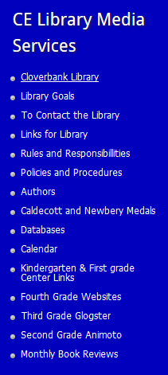Click Databases.

Choose World Book Encyclopedia. The username is froele and the password is 12345.

**Click**

Step 2: Click Kids.



Step 3: Now find the search bar. Enter in your topic (whatever you want info about) and click the magnifying glass.

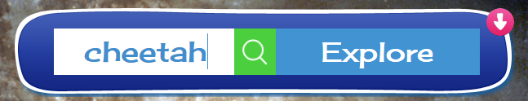

Step 4: Click the link that comes up that is about your topic. Make sure you spell the name of your topic right!   
